CURRICULUM VITAE (CV)
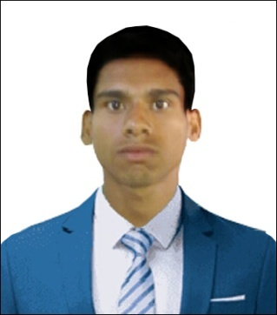

PARVEJ SK
Personal Details
Name - PARVEJ SK Nationality - Indian
Father’s Name - ABDUL KHALEK Sex - MALE
Mother’s Name - AMINA BIBI
Marital Status - Single Caste – GEN.
EXTRA CASTE – PHYSICALY HANDICAPED (OH – 80%)
Date Of Birth - 12th MAY 1996 Language Known – Bengali, Hindi, English
Present Address - Village – BAKHARPUR, P.O – KHANDUA
P.S – LALGOLA, DIST – MURSHIDABAD
STATE – WEST BENGAL, PIN NO – 742148
Email – Parvejsk9647@gmail.com Mob no. – 9647376047
8798003555

Academic Results
EXAM | BOARD | YEAR OF PASSING | MARKS | PERCENTAGE | GRADE
M.P | W.B.B.S.E | 2012 | 432 | 62 % | A

Computer and Technical Skill
EXAM | BOARD | YEAR OF PASSING | MARKS | PERCENTAGE | GRADE
C.I.T.A | Y.C.T.C | 2012 | 162 (200) | 81 % | A
D.I.T.A | Y.C.T.C | 2013 | 180 (200) | 90 % | A+
C.F.A | N.Y.C.T.C | 2014 | 241 (300) | 80.33 % | A

Computer & Technical skill –
Certified from THE INSTITUTE OF YOUTH COMPUTER TRAINING CENTRE, YCTC Lalgola, Murshidabad.
- Operating System: - windows 7/8/10/2000, Vista
- Microsoft office 2007 Professional.
- MICROSOFT EXCEL (Advance excel)
- Income Tax Calculation
- Knowledge of some other formulas like “COUNTIF” , “ROUND” , “INT” , “ROUNDDOWN” , “VLOOKUP”
- Microsoft Word, Access, PowerPoint
- Tally ERP 9.0. (Basic Knowledge)
- Accounting Entries.
- Accounting with inventories.
- VAT, CST, SERVICE TAX.
- TDS.
- POS invoice
- Maintain Payroll.
- Single payroll
- More than one payroll
- Internet knowledge.
- Knowledge browsing web pages.
- Downloading and uploading files.
- Online transactions.
Nil – job base experience.

Declaration
I hereby confirm that the above mentioned information is true. If given an opportunity to be a part of your esteemed concern; I will discharge my duties with sincerity and diligence.

